|  |  |  |
| --- | --- | --- |
| C:\Users\A04659\Desktop\数据中心\公司系统相关资料\关于明阳商标使用的温馨提示\01.png | Wind Turbine | **Date** |
| **2019-09-09** |
| **MingYang Monitoring System User Manual**   |  |  |  |  |  | | --- | --- | --- | --- | --- | | **Prepared by**  **王海存** | **Checked by**  **邓冬冬** | **Standardized by**  **田宛灵** | **Approved by**  **高宇洋** | **Released by**  **银磊** | |  |  |  |  |  |  |  |  |  |  | | --- | --- | --- | --- | | **Document No.** |  | **Revision** | **A** | | **Classification** | | **Number of pages** | **35** | | **□Strictly Confidential ■Confidential □ Secret □ Internal □Published** | | | | | | |

|  |
| --- |
| **Notification and Disclaimer**  This document may still be undergoing checking by the institution responsible, Although all work has been carried out very thoroughly; this document is still subject to changes. Without permission from MINGYANG, the risk of manufacturing that in accordance to this document or other uses is not in the responsibility of MINGYANG.  Should any information in this document be not complete, incomprehensible or faulty, it is the responsibility of the user of this document to immediately clarify the facts with the author and the client.  This document is only submitted under the assumption that the receiver accepts the above conditions. In case of any divergence of interpretations, the Chinese version shall prevail. |
|  |

**List of Valid Documents**

|  |  |  |  |
| --- | --- | --- | --- |
| **Item No.** | **Document Name** | **Document No.** | **Rev.** |
|  |  |  |  |
|  |  |  |  |
|  |  |  |  |
|  |  |  |  |
|  |  |  |  |

**List of Alterations**

|  |  |  |  |  |
| --- | --- | --- | --- | --- |
| **Item No.** | **Rev.** | **Modified Pages** | **Modifications** | **Date** |
|  |  |  |  |  |
|  |  |  |  |  |
|  |  |  |  |  |
|  |  |  |  |  |
|  |  |  |  |  |
|  |  |  |  |  |
|  |  |  |  |  |
|  |  |  |  |  |
|  |  |  |  |  |
|  |  |  |  |  |
|  |  |  |  |  |
|  |  |  |  |  |
|  |  |  |  |  |
|  |  |  |  |  |
|  |  |  |  |  |
|  |  |  |  |  |
|  |  |  |  |  |
|  |  |  |  |  |
|  |  |  |  |  |
|  |  |  |  |  |

**Content**

1．Overview of Monitoring System 5

2．Main Functions of Monitoring System 5

2.1 Data Acquisition Function 5

2.2 Data Processing Function 5

2.3 Security Monitoring Function 5

2.4 Screen Display 5

2.5 Logs and Reports 6

2.6 Control Function 6

3．Introduction to the Structure of Monitoring System 6

3.1 System Diagram of Main Equipment of Monitoring System 6

3.2 Network structure 6

3.3 Hardware Structure of Monitoring System 7

4．Monitoring System Equipment Maintenance and Matters Needing Attention 8

4.1 Network Maintenance 8

4.2 Server Maintenance 8

4.3 Operation Station Maintenance 8

5．Instructions for the Use of Monitoring System Software 9

5.1 Real-time Monitoring of Wind Field 9

5.2 Real-time Data Query 13

5.3 Data Query 14

5.4 Report Statistics Function 16

5.5 Curve Analysis 19

5.6 Box-type Transformer 26

5.7 Wind Turbine Generator System(WTGS) Control 26

5.8 Set up 28

# Overview of Monitoring System

The monitoring system of Mingyang Wind Farm mainly collects, monitors and controls the operation status and production operation data of wind turbine distributed in different locations in real time, so that the monitoring center can timely and accurately understand the production operation status of the wind turbine.

This manual serves as the user operation manual for the monitoring system of Mingyang Wind Farm, which is applicable to the central monitoring system of wind farm V1.5 and above. The following content mainly introduces the network structure of the entire system and the detailed functions and characteristics of each screen, with corresponding the picture instructions illustrate the steps.

# 2． Main Functions of Monitoring System

The monitoring system provides complete automated monitoring for the operation and management of the wind farm and provides data and information services for the upper-level system. The specific functions are as follows

## 2.1 Data Acquisition Function

Receive information such as wind turbine operating status, operating data, alarm code, real-time electrical energy data and other information sent from the main control system of each wind turbine.

## 2.2 Data Processing Function

* Generate real-time database of received data;
* Generate historical data records;
* Generate various operating reports;
* Generate all kinds of curve charts;
* With data statistics ability, summarizing wind turbine running time, active power, reactive power, available power, power accumulation, statistics and analysis
* Equipment failure alarm statistics and analysis, etc.

## 2.3 Security Monitoring Function

* Monitoring and management of equipment operating status and parameters.

## 2.4 Screen Display

* The monitoring system client can display various information screens of the wind turbine, mainly including real-time data of all measured values such as the running status of all wind turbines, power generation, and equipment temperature, various alarm information, alarms and records, etc.

## 2.5 Logs and Reports

* The monitoring system can generate and print operation logs and reports, including wind turbine parameter reports, power generation statistics reports, comprehensive statistics tables, etc.

## 2.6 Control Function

* Through the monitoring system, the wind turbine can be controlled and operated remotely.

# 3．Introduction to the Structure of Monitoring System

## 3.1 System Diagram of Main Equipment of Monitoring System

Figure 3.1 below:

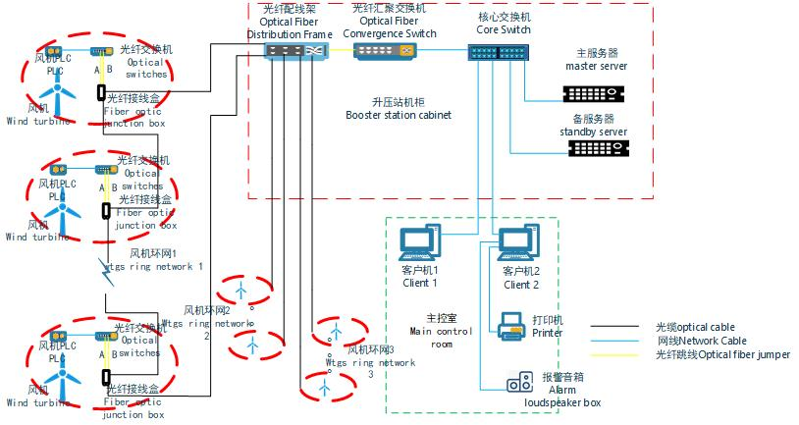

Figure 3.1 System Structure Diagram

## 3.2 Network Structure

The central monitoring system adopts a closed-loop network structure. Generally, each wind farm will be equipped with multiple closed-loop networks according to the environmental location and the number of wind turbine. Each wind turbine is equipped with an industrial-grade switch.

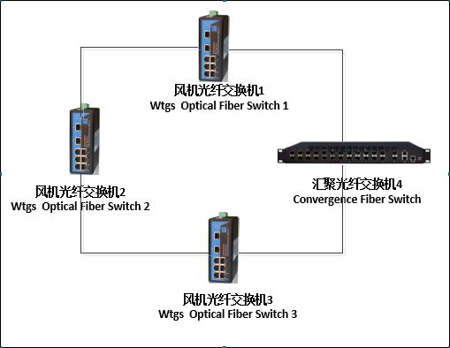

Figure 3.2 Loop Network Diagram

In the figure above, if all the networks between switch 1 and switch 4 are disconnected, all the communication between switch 1 and switch 4 can be obtained through switch 1, switch 2, switch 3 and switch 4. All the switching processes need not be interfered with manually, and no communication data will be lost. Therefore, any disconnection in the closed-loop network has no effect on network communication.

## 3.3 Hardware Structure of Monitoring System

## 3.3.1 Main Hardware Equipment of Monitoring System

Server, industrial grade switch, server cabinet, UPS power supply, operator station computer, etc.

### 3.3.2 Central Monitoring Room System

The central control room is equipped with 2 servers and 2 operation station computers as standard. The server is configured as one main and one standby dual server. The number of operator stations can be configured to a larger number according to user requirements, and the functions of each operator station are exactly the same without conflict with each other. One of the operation stations in the central control room is equipped with an alarm speaker as standard.

### 3.3.3 Tower Base Cabinet Monitoring System

The tower base cabinet monitoring system is mainly a monitoring system industrial switch. The switch is equipped with two optical ports and multiple electrical ports, and the switch power supply adopts the power supply of the tower base cabinet control system. All tower base cabinet industrial switches are connected to a closed loop network through optical ports.

The main equipment of the monitoring system configuration is as follows Table 4.1.

|  |  |  |  |
| --- | --- | --- | --- |
| Name | Quantity | Unit | Explanation |
| Data Server | 2 | Set | Real-time data acquisition, data processing, real-time database update and management, data query, etc. |
| Operator workstation | 2 | Set | Used for running the monitoring system software. The operation staff on duty monitors, controls and manages the wind turbine through the operator station. |
| Voice alarm speaker | 1 | Set | Used for voice alarm in case of wind turbine fails or abnormal. |
| Report Printer | 1 | Set | Printing of reports and related documents. |
| Core Switch | 1 | Set | The backbone network of the monitoring system. |
| Optical Fiber Convergence Switch | 1 | Set | For the access of optical fiber ring network signal. |
| UPS power supply | 1 | Set | Power supply guarantee for system and network equipment. |

Table 4.1 System Equipment Configuration Table

# 4．Monitoring System Equipment Maintenance and Matters Needing Attention

# 4.1 Network Maintenance

* Ensure smooth network communication and regularly check the operating status of switches and other equipment.
* Ensure the uninterrupted operation of network application services.
* Make a record of the identification of the network equipment connection line.

### 4.2 Server Maintenance

In order to better use and extend the service life of the server, it is necessary to maintain the server regularly. However, when maintaining the server, you must carefully handle the maintenance work, otherwise an error will have a great impact. The following information is for reference:

### 4.2.1 Uninstallation and Replacement of Equipment

The device must be unloaded and replaced when the power is completely cut off and the server is well grounded, even if it is a device that supports hot swap, to prevent static electricity from damaging the device.

### 4.2.2 Remove Dust

Dust is the biggest killer of the server, so it is necessary to dust the server regularly. For servers, dust is even fatal. The dust removal method is the same as the ordinary PC dust removal method, especially the dust removal of the power supply.

### 4.3 Operation Station Maintenance

The operator station must do a good job of anti-virus management, and it is prohibited to use U disk and other devices that may be infected with viruses on the operator station. Back up the current system on the operating station. If the operating station cannot start up and run normally, please restore the system when starting up.

Do not install any third-party software, let alone register unknown components.

# 5．Instructions for the Use of Monitoring System Software

### 5.1 Real-time Monitoring of Wind Field

### 5.1.1 Overview of wind turbine

The real-time monitoring interface mainly displays various real-time operating data of wind farms and wind turbines. After a successful login, the real-time monitoring interface of the wind farm is displayed by default, which is used to display the running status, wind speed and power of all wind turbines in the wind farm. The status includes five types: grid connection, standby, fault, maintenance, and no communication. Different states are distinguished by different colors. The main interface display is shown in Figure 5.1.

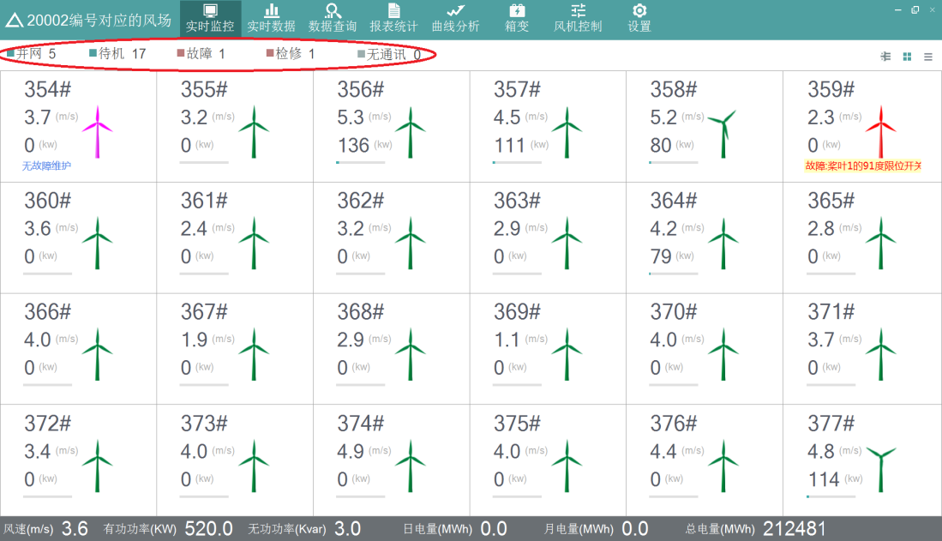

Figure 5.1 Main Interface Display Diagram

Click on the first button , you can switch the selected line to view the operating status of the wind turbine under this line, select line 1 as follows, and the wind turbine displayed at this time are the wind turbine under line 1, as shown in Figure 5.2.

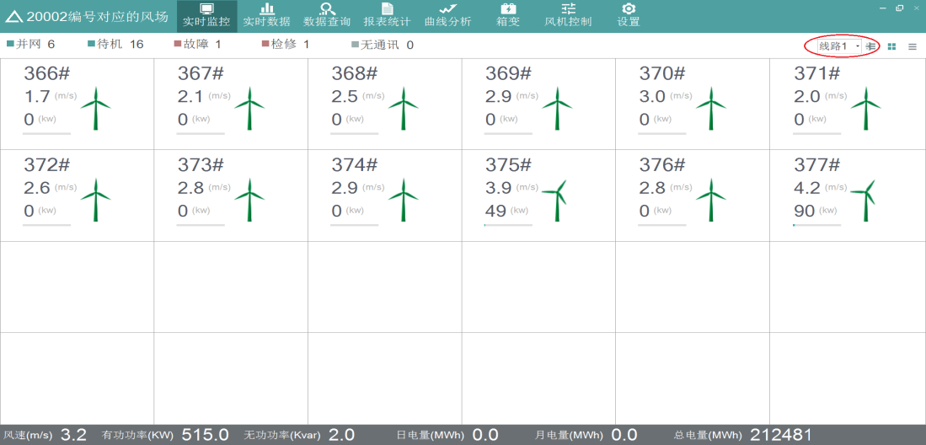

Figure. 5.2 Grouped Display of Wind Turbine Interface

Click on the second button  to switch back to the display of the whole wind turbines, as shown in Fig. 5.1.

Click on the third button , the information and status of the whole wind turbines are displayed in tabular form, as shown in Fig. 5.3.

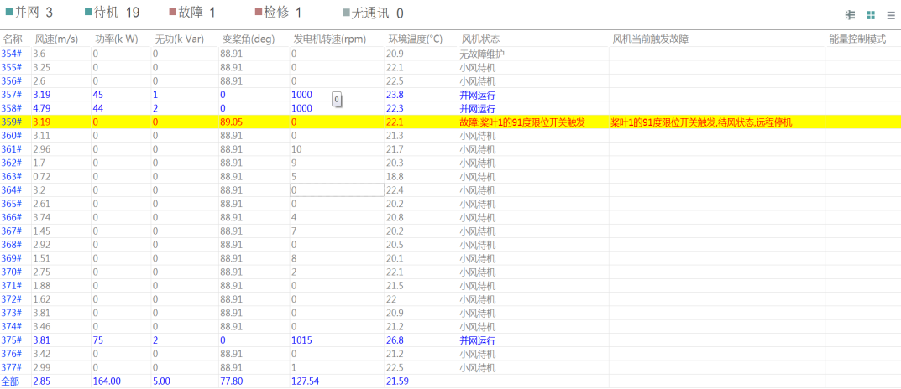

Figure 5.3 Table Display

The toolbar at the top of the main interface is the navigation bar. Click the button on the navigation bar to easily switch to each application page, as shown in Figure 5.4.



Figure 5.4 Application Page Diagram

### 5.1.2 Full field information refresh

The toolbar at the bottom of the main interface displays real-time wind speed, active power, reactive power, daily power, monthly power, and total power of the audience, as shown in Figure 5.5.



Figure 5.5 Toolbar Diagram

### 5.1.3 Real-time Monitoring of Wind Turbine

Click on a wind turbine on the main interface to enter the real-time monitoring interface of the wind turbine, and display the detailed information of the wind turbine, including all real-time data such as real-time power, wind speed, variable pitch angle, rotation speed and all signal data, basic information of the wind turbine and the owner. The current and recent faults, status and other historical records. It mainly includes the following functional interfaces, as shown in Figure 5.6.

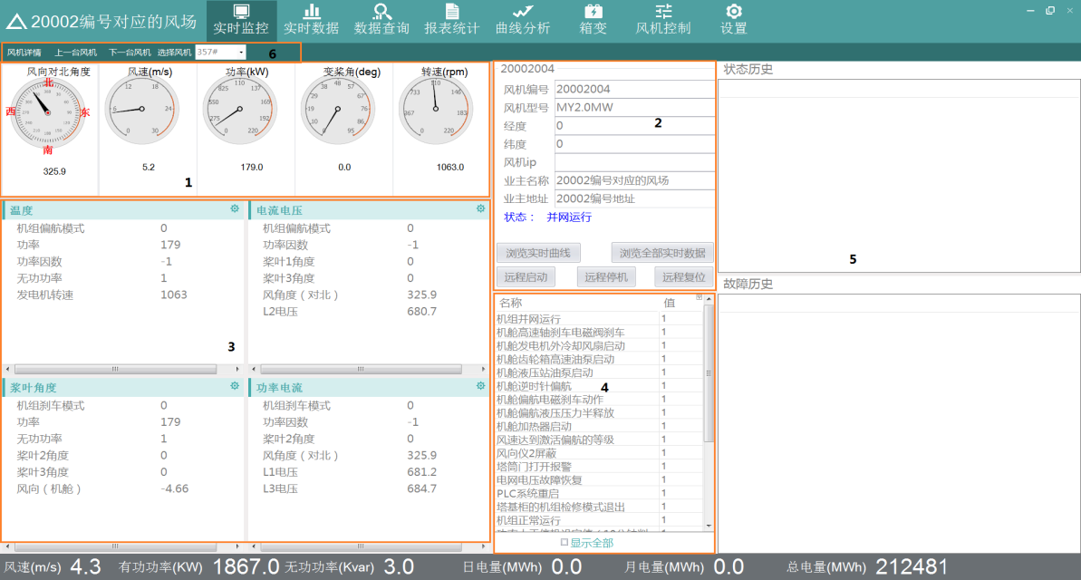

Figure 5.6 Interface Diagram of Wind Turbine Real-time Monitoring

The wind turbine overview page can be divided into six areas shown in the figure. Specific instructions are shown in Table 5.1.

|  |  |
| --- | --- |
| Serial number | Explanation |
| 1 | Intuitively display the wind direction of the wind turbine to the north angle, wind speed, power, variable pitch angle, and speed information with the dashboard. |
| 2 | Display the static information, status and some statistical information of the wind turbine, the name and address of the owner. |
| 3 | Start, stop, and reset the wind turbine, and browse real-time curves and real-time data. |
| 4 | Configurable to display the IO information of wind turbine. |
| 5 | Display SC Information of wind turbine. |
| 6 | Display the historical status and fault history of the last month. |
| 7 | Click on the previous wind turbine or the next wind turbine on the toolbar to select a wind turbine to quickly switch and display the selected wind turbine without switching back to the main interface. |

Table 5.1 Wind Turbine Page Description Table

### 5.1.4 Browse Real-time Curves

Click the "Browse Real-time Curve" button to view the real-time data of the current wind turbine. Select the time interval (20 minutes, 1 hour, 1 day). After the start time, click "Query" and the corresponding query curve will be displayed as shown in Figure 5.7.

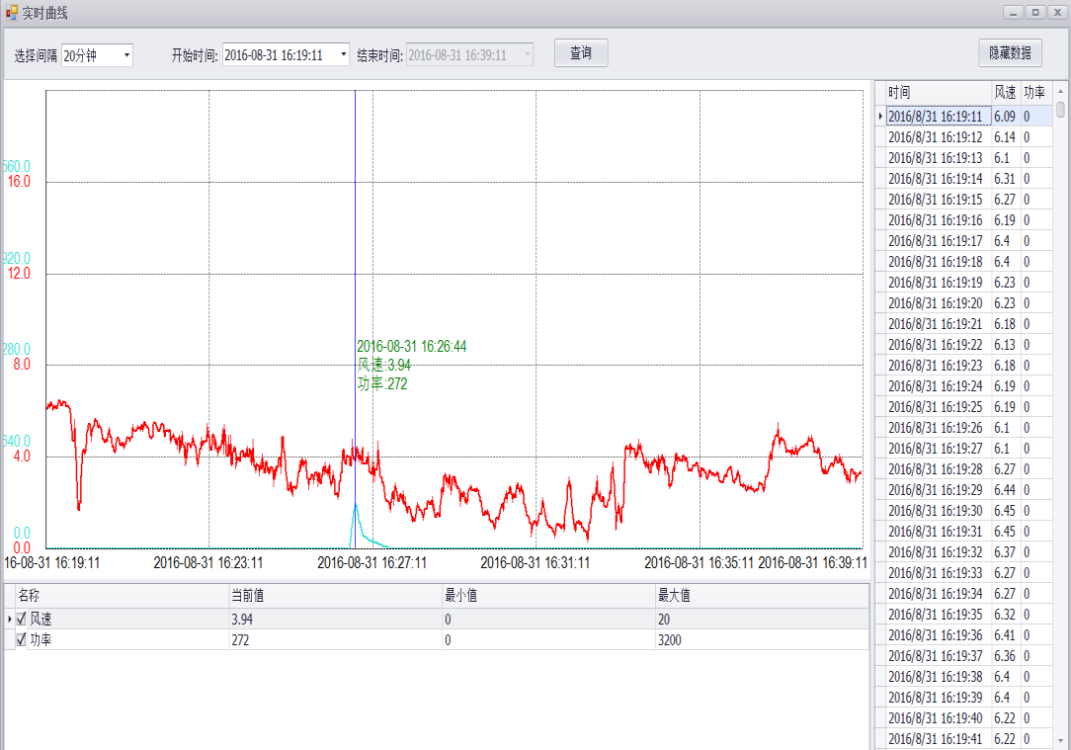

Figure 5.7 Query Chart

When the selection interval is 20 minutes, the query data interval is 1 second; when the selection interval is 1 hour, the query data interval is 3 seconds; when the selection interval is 1 day, the query data interval is 1 minute.

Click on the IO below to change its check status, and the display of the corresponding curve and the list on the right will change accordingly. Click on the curve, the time at that point and the corresponding IO value will be displayed.

Click "Hide Data", the table on the right will be hidden, and the corresponding button will become "Show Data". Click "Display Data", the table on the right will be displayed, and the button will change to "Hide Data".

### 5.1.5 Browse all real-time data

Click "Browse all real-time data" to view all real-time IO information of the wind turbine. As shown in Figure 5.8.

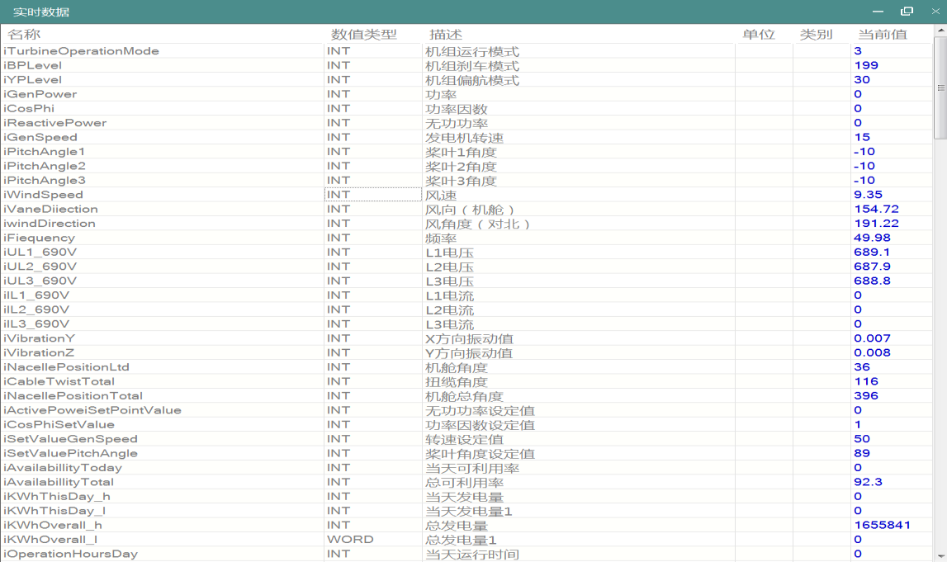

Figure 5.8 Real-time Data Graph

### 5.1.6 Remote Start, Remote Shutdown and Remote Reset

Click the "Remote Start", "Remote Stop" and "Remote Reset" buttons to start, stop and reset the wind turbine.

### 5.1.7 Configure IO Information

Click in area 3, in the analog selection interface, you can configure and select the wind turbine IO information to be displayed, as shown in Figure 5.9.

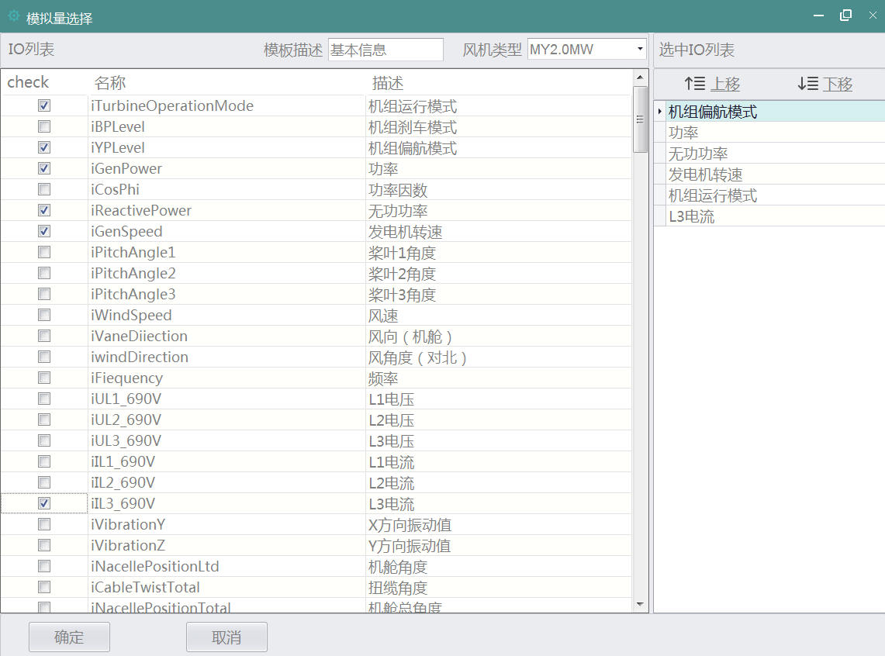

Figure 5.9 Analog Quantity Selection Diagram

In Figure 5.9, the left side is a list of all IOs of a wind turbine type, and the right side is a list of selected IOs. Click IO in the IO list on the left, check is the selected state, and this IO is added to the selected IO list. In the IO list selected on the right, the order of IO list can be adjusted by dragging and dropping the node and the "Move up" and "Move down" buttons. After the operation is completed, click the "OK" button, and the selected IO will be added to the real-time data list. Click the "Cancel" button to close the window.

### 5.2 Real-time Data Query

Click the "Real-time Data" button on the toolbar above the main interface to view the real-time data of all wind turbines. The red one indicates fault, the blue one indicates grid connection, and the gray one indicates no communication, as shown in Figure 5.10.

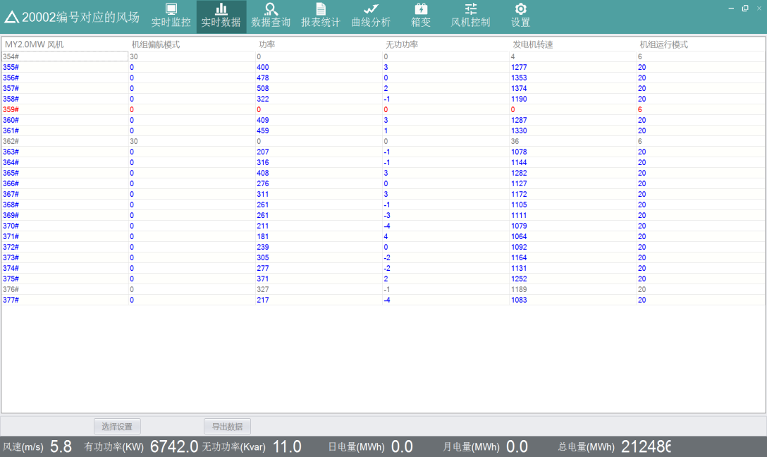

Figure 5.10 Real-time Data Graph

Click the "Select Settings" button, in the analog quantity selection interface, you can configure and select the IO information of the wind turbine to be displayed. Click "Export Data" to export real-time data in CSV format to the local.

### 5.3 Data Query

Click the "Data Query" button on the toolbar above the main interface to view the fault data, status data, minute data, Tracelog data, and StatusCode data of the wind turbine.

### 5.3.1 Fault Data Query

Click "Data Query" -> "Fault Data", first select the wind turbine to be queried in the wind turbine list on the left, and then select the start time and end time of the query on the top. After selecting the query conditions, click "Query", and the results of the query will be displayed in the table, including the fault name, the start and end time of the fault, and the duration of the fault. Click "Export" to export the query result in CSV format to the local. As shown in Figure 5.11.

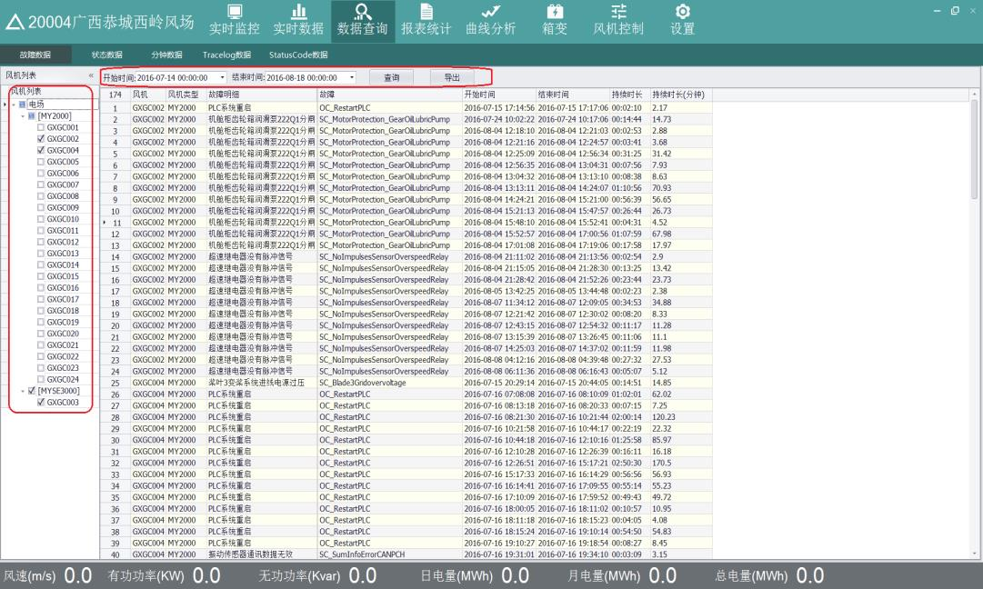

Figure 5.11 Data Export Diagram

### 5.3.2 State Data Query

Click "Data Query" -> "Status Data", first select the wind turbine you want to query in the wind turbine list on the left, and then select the start time and end time of the query on the top. After selecting the query conditions, click "Query", and the results of the query will be displayed in the table, which mainly includes the wind turbine type, status code and status description, first touch code and first touch code description, etc. Click "Export" to export the query result in CSV format to the local. As shown in Figure 5.12.

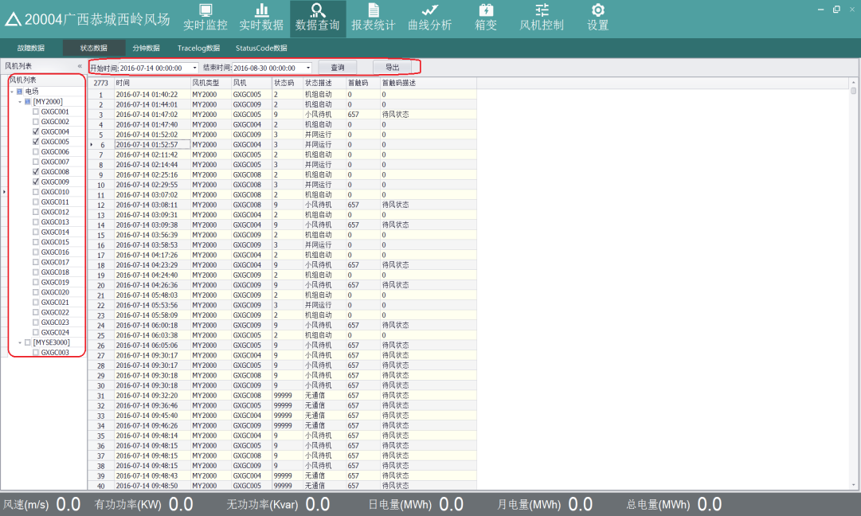

Figure 5.12 Status Data Diagram

### 5.3.3 Minute Data Query

Click "Data Query" -> "Minute Data", first select the wind turbine to be queried in the wind turbine list on the left, then select the IO amount to be queried in the corresponding IO list in the middle, and finally select the data type to be queried on the top ( The default is ten minutes of data), the start time and end time of the query. After selecting the query conditions, click "Query", and the query results will be displayed in the table, which mainly includes the time, the number of wind turbine selected and the IO information selected. Click "Export" to export the query result in CSV format to the local. As shown in Figure 5.13.

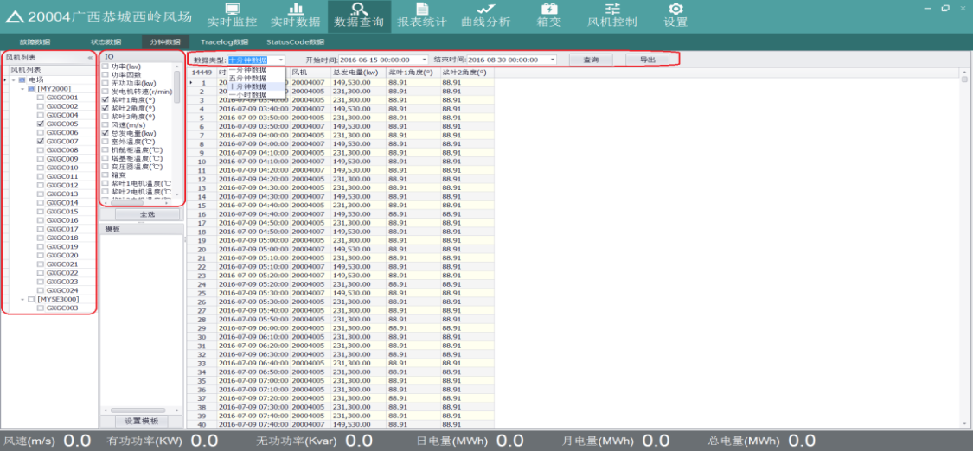

Figure 5.13 Minute Data Diagram

Note: Only the wind turbine of the same type can be selected for query, because different types of wind turbine correspond to different IOs. In the figure, click the "Select All" button to select all IOs.

### 5.4 Report Statistics Function

Click the "Report Statistics" button in the toolbar on the main interface to view the wind turbine power generation statistics, wind turbine performance statistics and lost power generation.

### 5.4.1 Power Generation Statistics

Click "Report Statistics" -> "Power Generation Statistics", first select the wind turbine to be queried in the list of wind turbine on the left, and then select the time interval type (hour, day, month), start time and end time of the query on the top. After selecting the query conditions, click "Query", and the results of the query will be displayed in the table, including wind turbine, wind turbine types, time, average wind speed, maximum wind speed, minimum wind speed, and power generation. Click "Export" to export the query result in CSV format to the local. Click "Export" to export the query results to the local area in CSV format.

Select "Times", the query result is shown in Figure 5.14, and the query interval is 1 hour. The upper table is the specific query information of the selected wind turbine, and the lower table is the total information of the selected wind turbine type and the total information of the whole wind farm.

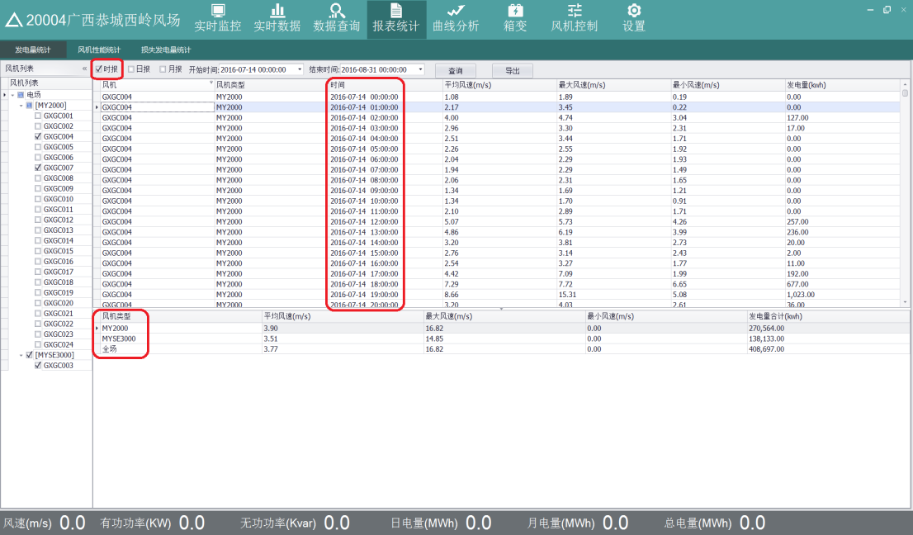

Figure 5.14 Hour Query Result Diagram

● Select "Daily", the query interval is 1 day, as shown in Figure 5.15.. 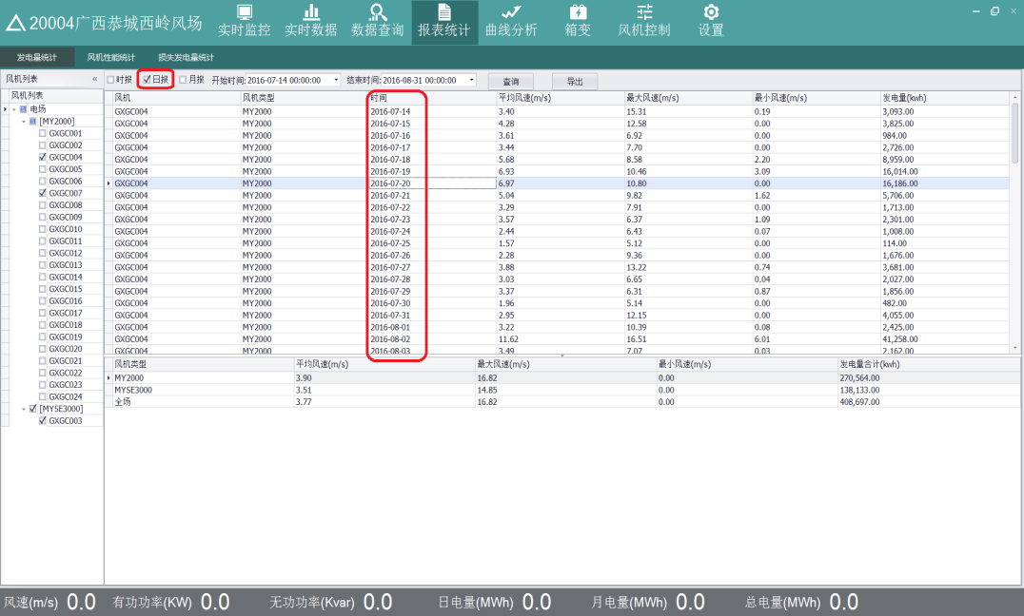

Figure 5.15 Daily Query Result Diagram

● Select "Monthly Report", the query interval is 1 month, as shown in Figure 5.16.

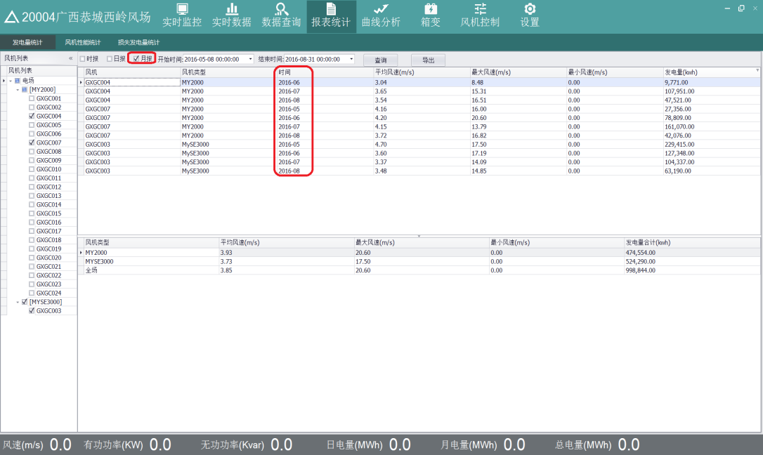

Figure 5.16 Query Result Diagram of Monthly Report

### 5.4.2 Performance Statistics of Wind Turbine

Click "Report Statistics"> "Wind Turbine Performance Statistics". First select the wind turbine you want to query in the wind turbine list on the left, and then select the start time and end time of the query on the top. After selecting the query conditions, click "Query", and the results of the query will be displayed in the table. The upper table is the information about the selected wind turbine, and the lower table is the information of the whole venue, including wind turbine, wind speed, effective wind hours, power generation hours, and equivalent utilization hours, power generation, number of failures, number of failure hours, availability rate. Click "Export Details" to export the wind turbine information in the above table to the local in CSV format. Click "Export Full Site" to export the full field information in the table below to the local in CSV format. As shown in Figure 5.17.

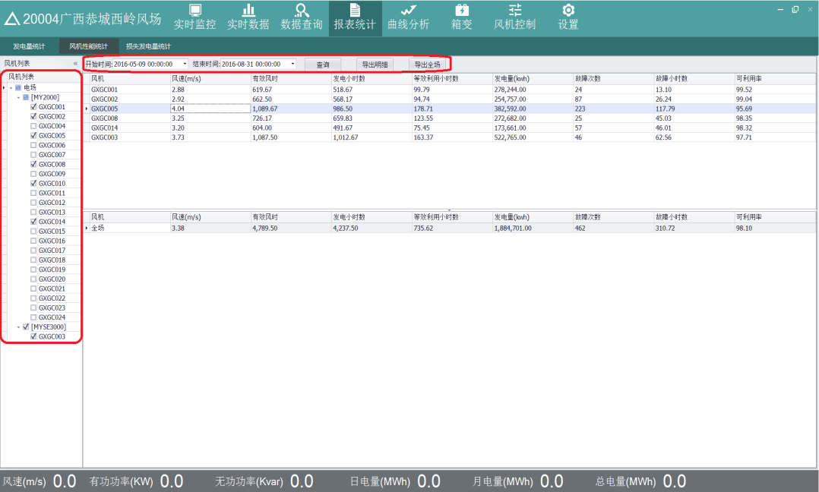

Figure 5.17 Statistical Chart of Wind Turbine Performance

### 5.4.3 Statistics of Lost Power Generation

Click " Report Statistics " -> "Statistics of Lost Power Generation", first select the wind turbine to be queried in the wind turbine list on the left, and then select the start time and end time of the query on the top. After selecting the query conditions, click "Query", and the results of the query will be displayed in the table, which mainly include wind turbine, theoretical power generation, actual power generation, and fault lost generating capacity. Click "Export" to export the queried information to the local in CSV format. As shown in Figure 5.17

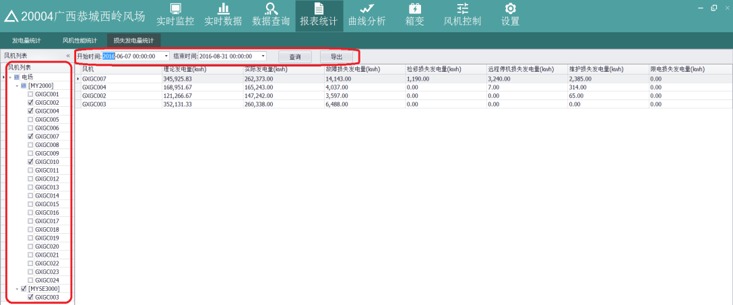

Figure 5.17 Statistical Chart of Lost Power Generation

### 5.5 Curve Analysis

Click the "Curve Analysis" button in the toolbar on the main interface to view the power curve, free trend (single unit and multiple points), free trend (multiple units and single point), relationship curve, and wind frequency graph of the wind turbine.

### 5.5.1 Power Curve

Click "Curve Analysis" - > "Power Curve". First select the wind turbine you want to query in the wind turbine list on the left, and then select the start time and end time of the query, and the curve category on the top.

When the curve type is a trend graph, up to three wind turbines of the same type can be selected; when the curve type is a scatter graph, only one wind turbine can be selected. After selecting the query conditions, click "Query", the power curve is shown in Figure 5.18 (Trend Graph) and Figure 5.19 (Scatter Plot), the abscissa is wind speed, and the longitudinal ordinate is power.

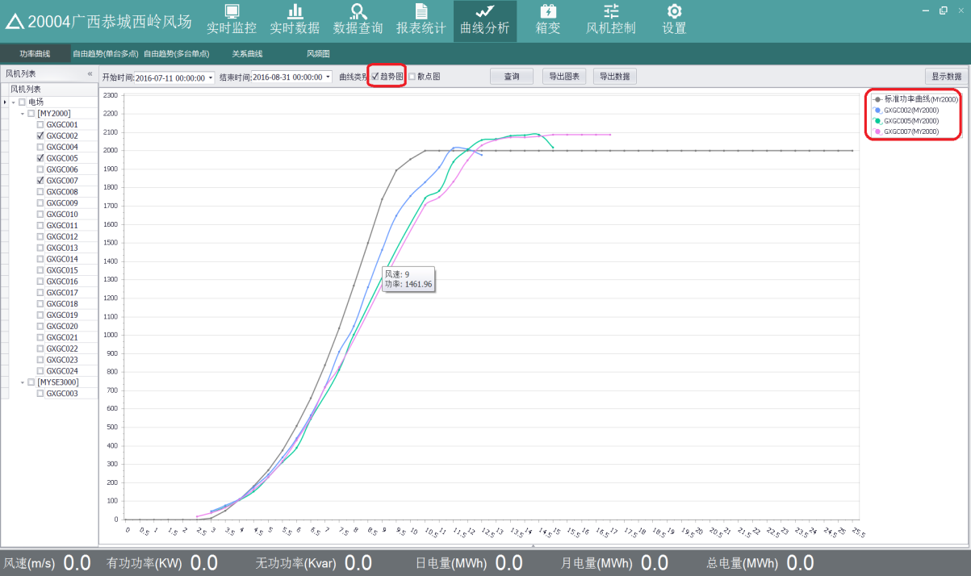

Figure 5.18 Trend Graph

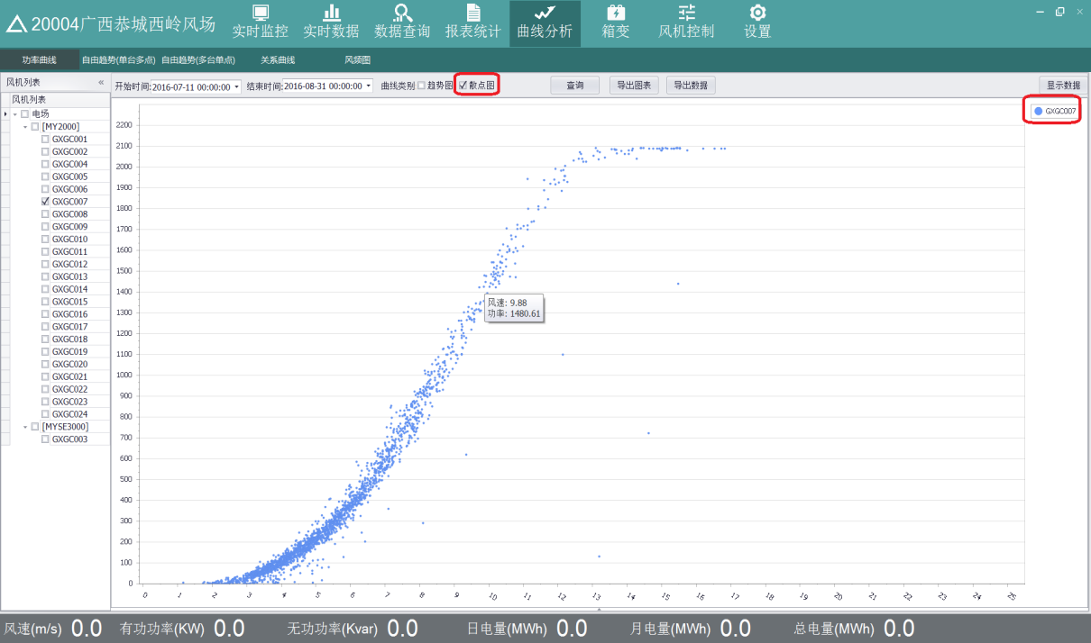

Figure 5.19 Scatter Plot

When the mouse moves to the point on the curve, the coordinates of the current point will be displayed, that is, the wind speed and power value of the point. The curve is displayed in different colors, and the color of the curve is consistent with the curve name in the upper right corner.

Click "Export Chart" to export the curve and save it locally.

Click "Export Data" to save the result data of the query to the local in CSV format.

Click "Display Data" to display the result data of the query in the table, as shown in Figure 5.20

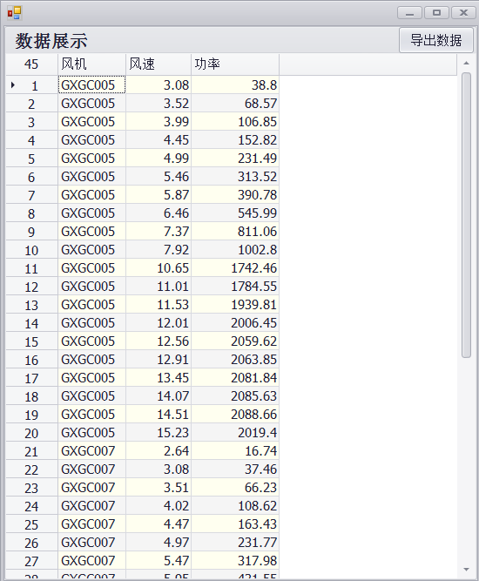

Figure 5.20 Wind Speed Power Data Display Diagram

### 5.5.2 Free Trend (Single Station and Multiple Points) Click "Curve Analysis" -> "Free Trend (Single station and multiple points)", Single station and multiple points refers to selecting a wind turbine, multiple IO points for query, the amount of IO cannot exceed 3. First, select a wind turbine in the wind turbine list on the left, then select the IO to be queried from the IO list in the middle, and finally select the start time and end time of the query. The selection time interval cannot be greater than 7 days. After selecting the query conditions, click "Query", the curve is displayed as shown in Figure 5.21.

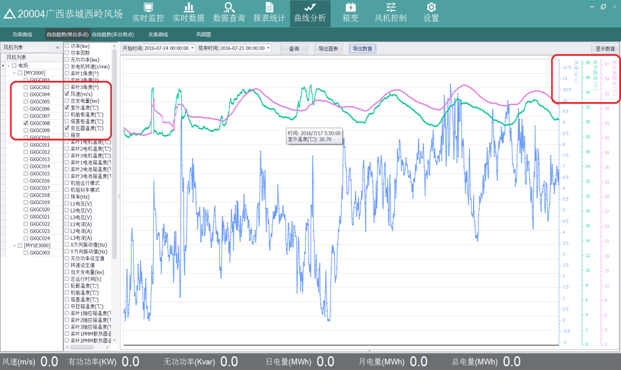

Figure 5.21 Free Trend Chart

When the mouse moves to a point on the curve, the value of the current point will be displayed. The abscissa is the time and the ordinate are the value of the corresponding IO. This curve is a multi-ordinate axis. Each IO corresponds to a coordinate axis. The curve uses different colors indicates that the color of the curve is consistent with the curve name in the upper right corner.

Click "Export Chart" to export the curve and save it locally.

Click "Export Data" to save the result data of the query to the local in CSV format.

Click "Display Data" to display the result data of the query in the table, as shown in Figure 5.22.

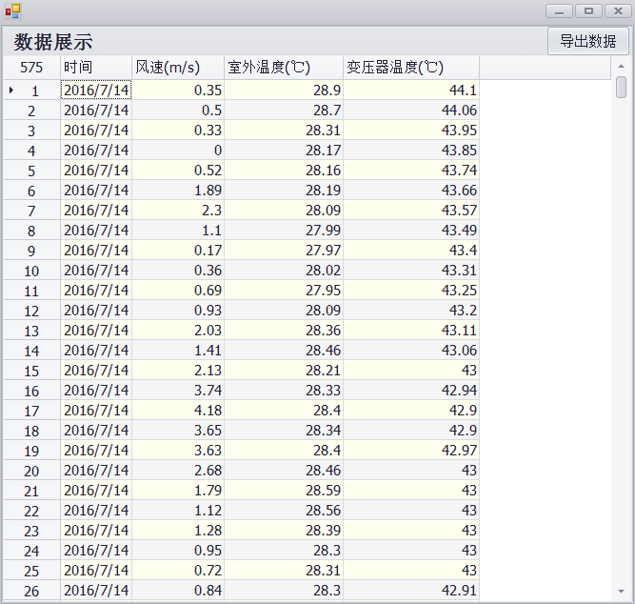

Figure 5.22 Wind speed and temperature data display diagram

### 5.5.3 Free Trends (Multiple Stations and Single Point)

Click "Curve Analysis" -> "Free Trend (Multiple Stations and Single Point)". Multiple Stations and Single Point refer to the selection of multiple wind turbines and a single IO point for query. The selected wind turbine types must be the same, because different types of wind turbines correspond to the amount of IO is different. First, select multiple wind turbines in the wind turbine list on the left, and then select the IO to be queried from the IO list in the middle, and finally select the start time and end time of the query. The selection time interval cannot be greater than 7 days. After selecting the query conditions, click "Query" and the curve will be displayed as shown in Figure 5.23.

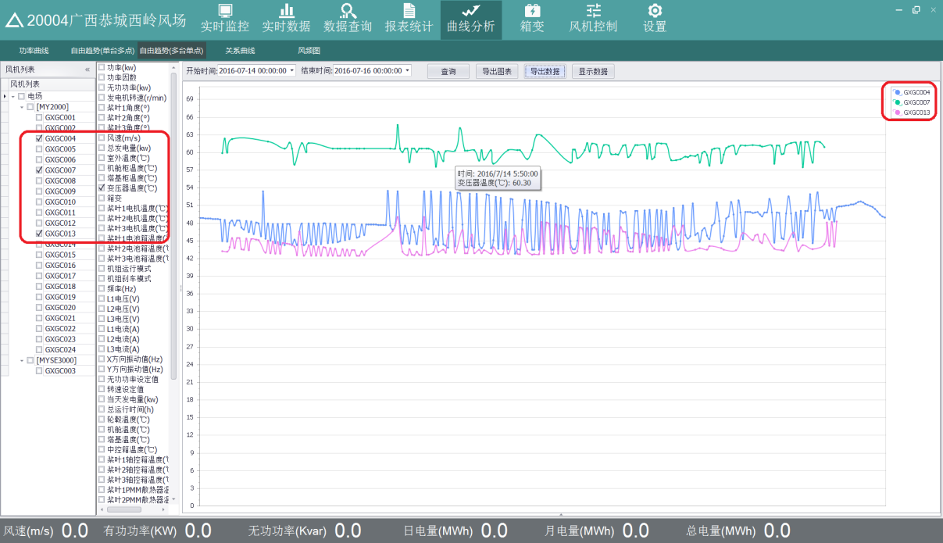

Figure 5.23 Curve Display Diagram

When the mouse moves to a point on the curve, the value of the current point will be displayed. The abscissa is the time, and the ordinate is the value of the corresponding IO. Curves are expressed in different colors, and the color of the curve is consistent with the curve name in the upper right corner.

Click "Export Chart" to export the curve and save it locally.

Click "Export Data" to save the result data of the query to the local in CSV format.

Click "Display Data" to display the result data of the query in a table, as shown in Figure 5.24.

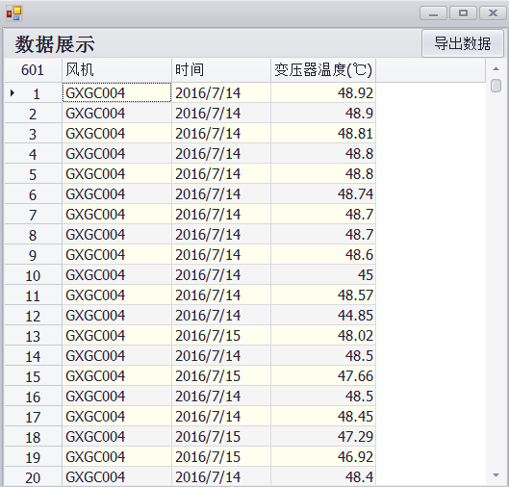

Figure 5.24 Temperature Data Display Chart

### 5.5.4 Relational Curve

Click "Curve Analysis" -> "Relational Curve", first select a wind turbine in the wind turbine list on the left, then select two IO quantities in the middle IO list, and finally select the start time and end time of the query. After selecting the query conditions, click "Query", and the curve relationship between the two IO quantities is displayed as shown in Figure 5.25

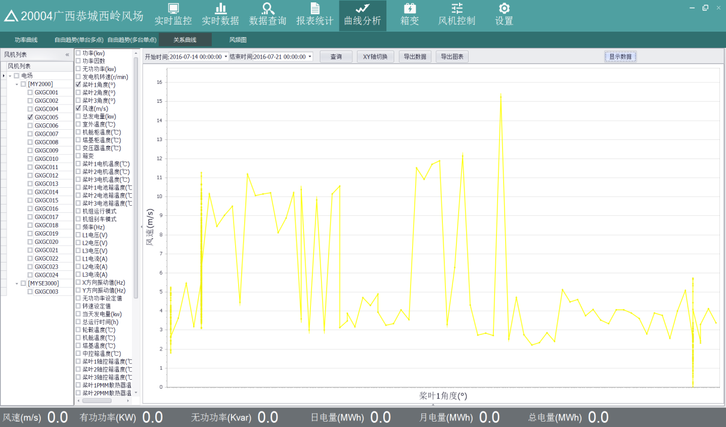

Figure 5.25 Curve Diagram

In the figure, the two IOs selected are the angle and wind speed of blade 1, the abscissa of the curve is the angle of blade 1, and the ordinate is the wind speed, and the curve represents the trend graph of the relationship between them. Click "XY axis switch" to exchange the coordinates of the curve. The abscissa is the wind speed and the ordinate is the angle of blade 1, as shown in Figure 5.26.

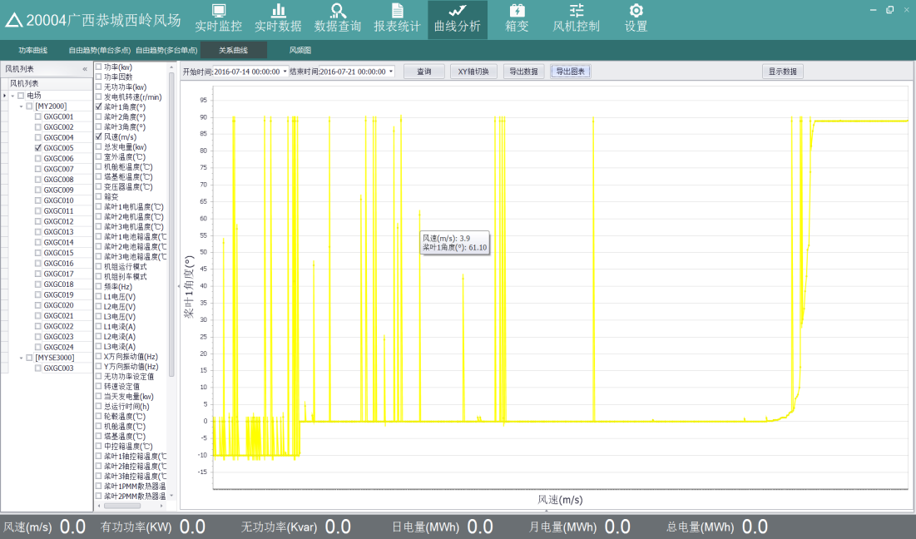

Figure 5.26 Angle and Wind Speed Diagram

Click "Export Chart" to export the curve and save it locally.

Click "Export Data" to save the result data of the query to the local in CSV format.

Click "Display Data" to display the result data of the query in a table, as shown in Figure 5.27.

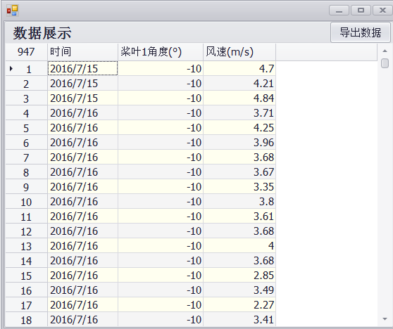

Figure 5.27 Angle Wind Speed Data Display

### 5.5.5 Wind Frequency Diagram

Click "Curve Analysis" -> "Wind Frequency Diagram". First select the wind turbine in the wind turbine list on the left, select up to 3 units, and then select the start time and end time of the query. After selecting the query conditions, click "Query", the curve will be displayed as shown in Figure 5.28. The abscissa is wind speed and the ordinate is wind frequency.

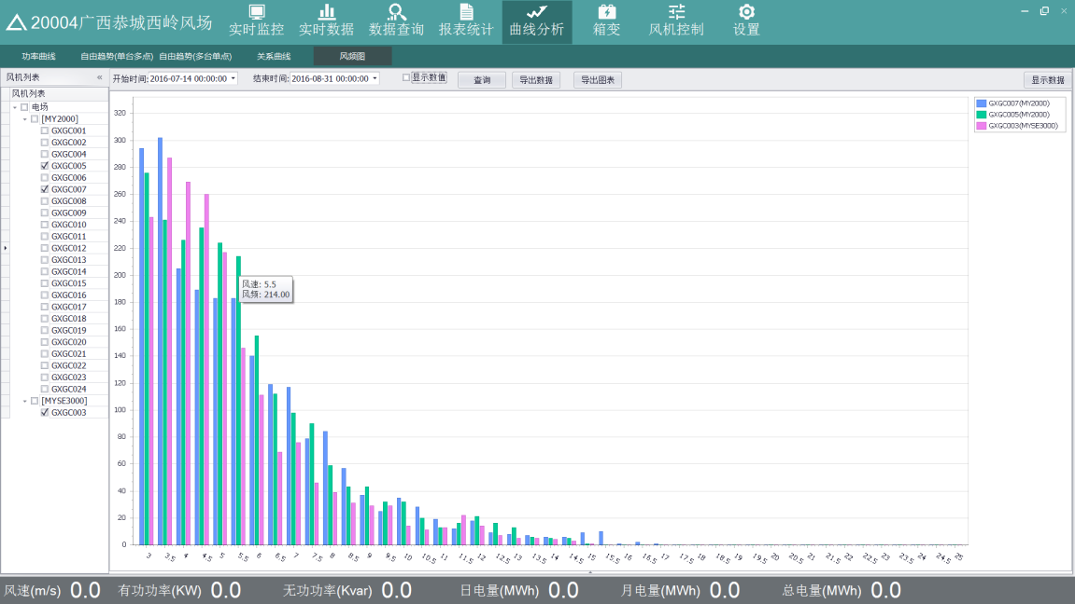

Figure 5.28 Wind Frequency Diagram

Click "Display Value", the value of each point will be displayed on the curve, as shown in Figure 5.29.

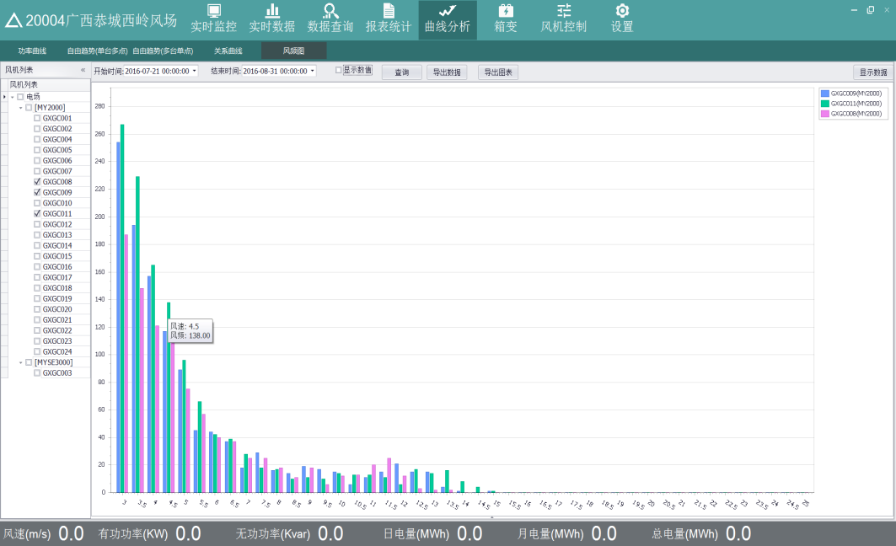

Figure 5.30 Curve Value Display Graph

Click "Export Chart" to export the curve and save it locally.

Click "Export Data" to save the result data of the query to the local in CSV format.

Click "Display Data" to display the result data of the query in a table, as shown in Figure 5.31.

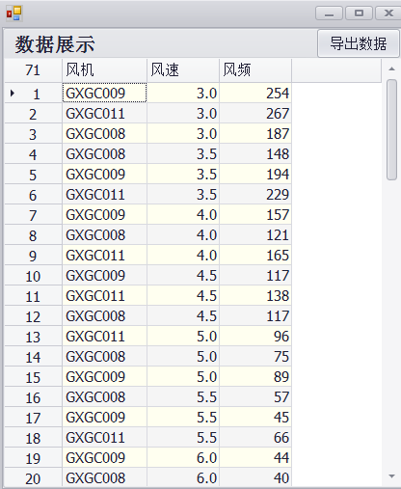

Figure 5.31 Wind Speed and Frequency Data Display Chart

### 5.6 Box-type Transformer

Click the "Box-type Transformer" button on the toolbar above the main interface to view the IO and SC values of the box-type transformer of the wind turbine. Click a box-type transformer on the left, and the corresponding IO and SC will be displayed on the right, as shown in Figure 5.32.

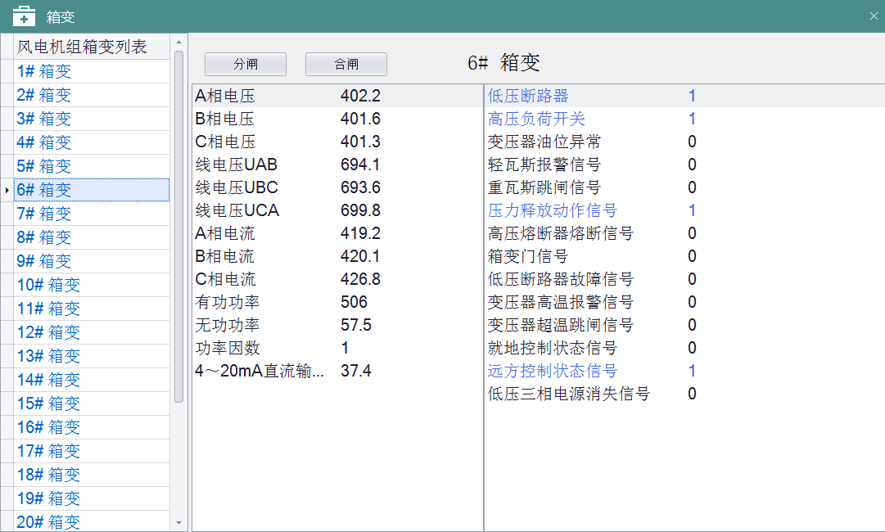

Figure 5.32 Box-type Transformer Display Diagram

Select the box-type transformer and click "Switch-off" or "Switch-on" to close or open the switch.

### 5.7 Wind Turbine Generator System(WTGS) control

Click the " WTGS Control" button in the toolbar on the main interface to perform control-related operations on the wind turbine, and all control actions will be saved in corresponding records.

You can select a single wind turbine, multiple or all of them. Click "Select All" to select all wind turbines. Click "Reverse Selection" to uncheck. As shown in Figure 5.33.

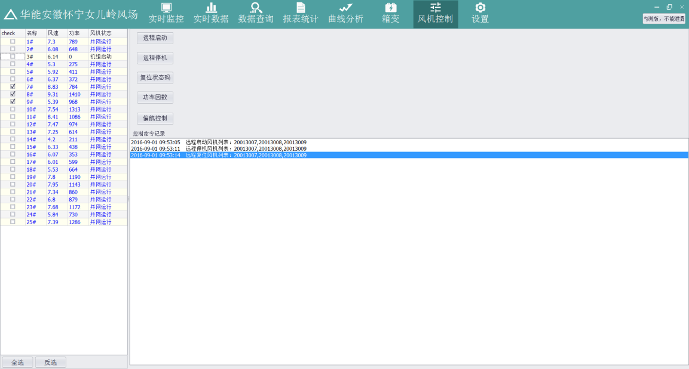

Fig. 5.33 WTGS Control Chart

### 5.7.1 Wind Turbine Start-up and Shutdown

After selecting the wind turbine, click "Remote Start" or "Remote Stop" to start and stop the wind turbine.

### 5.7.2 Wind Turbine Reset

After selecting the wind turbine, click "Reset Status Code" to reset the wind turbine accordingly

### 5.7.3 Power Factor

Click "Power Factor" to set the power factor of the wind turbine manually. Select a wind turbine and enter the value in the edit box after the power factor on the right, the range of the power factor value is 0.95~1. Click "Modify" to save to the current power and the factor value column becomes active. Click "Disable" to disable the power factor of the wind turbine. As shown in Figure 5.34.

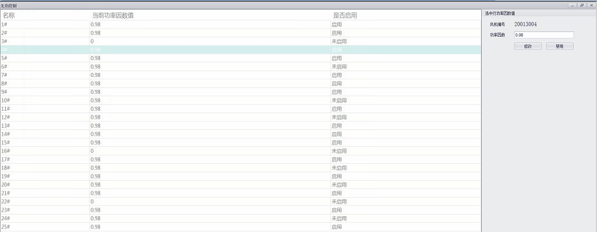

Figure 5.34 Power Factor Diagram

### 5.7.4 Yaw Control

Click "Yaw Control" to control the wind turbine automatically or manually, as shown in Fig. 5.35. 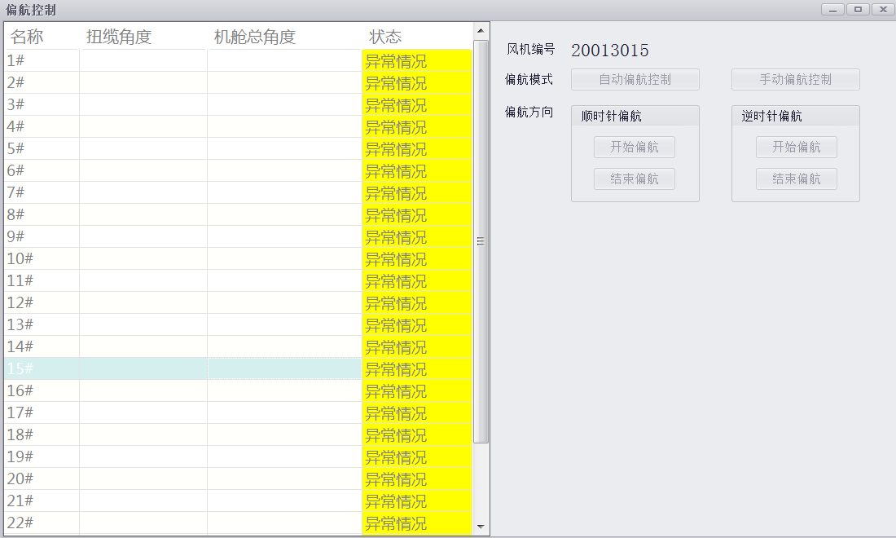

Figure 5.36 Yaw Control Chart

When the wind turbine status is abnormal, it cannot be operated. When it is automatic or manual, automatic yaw control or manual yaw control can be selected on the right side. When automatic yaw control is selected, there is no need to operate the yaw direction. When selecting manual yaw control, it is necessary to operate the yaw direction, yaw clockwise or yaw counterclockwise.

### 5.8 Set up

Click the "Settings" button on the toolbar above the main interface to view the current system client version and server version.